Lab 6: RLC resonance, Bandwidth and Quality Factor

Objectives

Investigate the resonance phenomena in an RLC circuit. Analyze the Resonant Frequency and Bandwidth of the given circuit and determine the effect of the load resistance on the Quality Factor.

Resonance in a series RLC circuit

Resonance is a condition in an RLC circuit in which the capacitive and inductive reactances are equal in magnitude, thereby resulting in a purely resistive impedance. Consider the series RLC circuit in Figure 1.
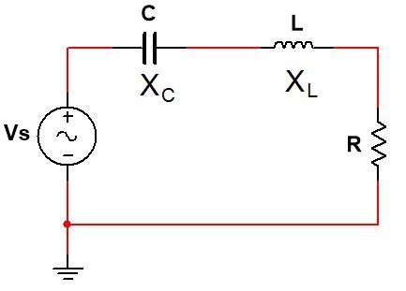
Fig.1 Series RLC circuit

Here, both X_{C} and X_{L} are frequency dependent. However, X_{C} is inversely proportional to frequency and X_{L} is directly proportional. That is, as the frequency is increased, X_{C} decreases and X_{L} increases. This means there must be a source frequency for which X_{C} = X_{L}. A circuit operating in that frequency is said to be in resonance condition.At the resonance condition, X_{C} = X_{L}, which means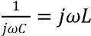. This expression can be simplified to obtain the following expression for the resonance frequency, f₀.
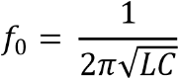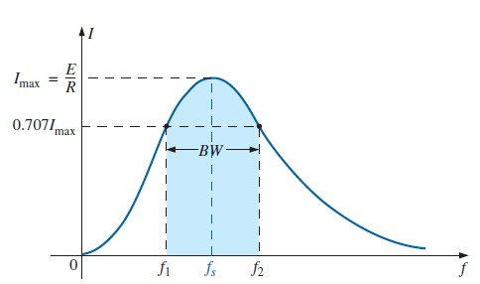

Fig.2

Now, the impedance in the above circuit can be expressed as: . Therefore, at resonance condition, the impedance of the circuit is purely resistive, which means that the entire source voltage is across R. At any other operating frequency, the voltage across R will be lower due to the non-zero reactance contributing to the total impedance.

Bandwidth and Quality Factor

If the series RLC circuit is driven by a variable frequency at a constant voltage, then the magnitude of the voltage, V is proportional to the impedance, Z. Therefore, at resonance the power absorbed by the circuit must be at its maximum value.

If we now reduce or increase the frequency until the average power absorbed by the resistor in the series resonance circuit is half that of its maximum value at resonance, we produce two frequency points called the half-power points or half-power frequencies. These points give us a voltage value that is 70.7% of its maximum resonant value. That is, at the upper and lower cut-off frequencies, say f₁ and f₂, V = 0.707V_{max}. The difference between these two points (f₁ – f₂) is called the Bandwidth (BW) of the circuit. This bandwidth is also known as the half-power bandwidth.

The “sharpness” of the resonance in a resonant circuit is measured quantitatively by the Quality Factor (Q).The quality factor relates the maximum or peak energy stored in the circuit (the reactance) to the energy dissipated (the resistance) during
each cycle of oscillation meaning that it is a ratio of resonant frequency to bandwidth 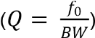 and the higher the circuit Q, the smaller the bandwidth.

Apparatus

Components | Instruments
- Resistors: 1×100Ω (R1), 1×200Ω (R2)  - Capacitors: 1×0.1µF  - Inductor: 1x330µH | - 1× Trainer Board  - 1× Function Generator  - 1× Dual Channel Oscilloscope  - Connecting wires and probes

Constructing the circuit :

- Construct the circuit shown in Fig.3 on the bread board. Use minimal wires.
- Set 1 kHz Frequency and 3V peak Amplitude (6V peak to peak) in the Function Generator.
- Connect Channel 1 of the oscilloscope across the source V_{S} (positive red port to node „a‟ and negative black port to node „0‟ i.e. ground).
- Observe the generated signal on the oscilloscope screen and fine tune the frequency and amplitude of the input signal generated from the function generator to match the nominal values. Always set the amplitude after setting the frequency because changing the frequency of a non-ideal source might alter the amplitude.
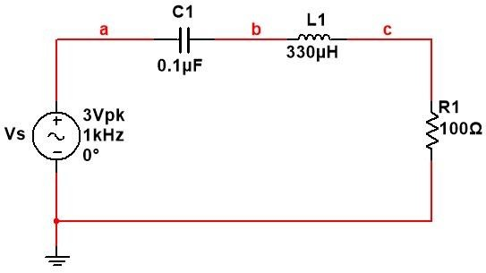
Fig.3 Series RLC circuit


=(1X10⁶)/36.07 Hz
=27.7 KHz

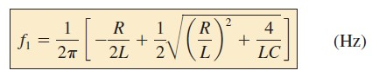

=

(
1
/6.28)[(
-
100/660X10
-
6
)+0.5
√
(100/330X10
-
6
)
2
+4
/(330X
10
-
6
)(0.1X10
-
6
)]

= 0.159[-0.1515X10⁶+0.5√ 0.091X (10⁶)²+ 0.1212X (10⁶)²)]

= 0.159[-0.1515X10⁶+0.23X10⁶]
= 0.159[0.0788X10⁶]
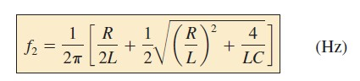

=

12.53
KHz

= (1/6.28)[(100/660X10⁻⁶)+0.5√ (100/330X10⁻⁶)²+4/(330X10⁻⁶)(0.1X10⁻⁶)]

= 0.159[0.1515X10⁶+0.23X10⁶]
= 0.159[0.3815 X10⁶]
= 60.65 KHz

Student Information

Section: 03 | Group: 03 | Status:

Table 1.1: Component Values

 | R₁(Ω) | R₂ (Ω) | C₁(F) | L₁(H)
Nominal | 100 Ω | 200 Ω | 0.1 uF | 330 uH
Measured | 100.4 Ω | 200.1 Ω | 0.11 uF | 317.3 uH

Table 1.2: The magnitudes of V_{R} at different frequencies for a high Q circuit

Frequency (f) kHz | Peak Voltage,  V_{R}(V) | I_{peak}(mA)
1 | 240 mV | 2.39 mA
10 | 1.76 V | 17.5 mA
20 | 2.76 V | 27.5 mA
25 | 2.88 V | 28.69 mA
27.7 | 2.92 V | 29.08 mA
30 | 2.92 V | 29.08 mA
40 | 2.80 V | 27.89 mA
50 | 2.60 V | 25.9 mA
70 | 2.12 V | 21.12 mA
100 | 1.60 V | 15.94 mA
120 | 1.36 V | 13.55 mA

Table 1.3: Resonant frequency, Quality Factor and Bandwidth for a high Q circuit

 | Theoretical, (a) | Experimental,  (b) | Deviation (%),  𝒂 − _{𝒂} × 𝟏𝟎𝟎  𝒃
f₀ (KHz) | 27.7 kHz | 27.7 kHz | 0 %
f₁ (KHz) | 11.7 kHz | 13.06 kHz | 11.62 %
f₂ (KHz) | 62.05 kHz | 73.25 kHz | 18.05 %
Bandwidth (f₂ – f₁) (KHz) | 50.35 kHz | 60.19 kHz | 19.54 %
fo/ Q-factor( ) Bandwidth | 0.55 | 0.46 | 16.36 %

Table 1.4: The magnitudes of V_{R} at different frequencies for a low Q circuit

Frequency (f) kHz | Peak Voltage,  V_{R}(V) | I_{peak}(mA)
1 | 400 mV | 1.99 mA
20 | 2.96 V | 14.79 mA
25 | 3 V | 14.99 mA
26 | 3.02 V | 15.09 mA
27 | 3.02 V | 15.09 mA
27.7 | 3.02 V | 15.09 mA
28 | 3.02 V | 15.09 mA
30 | 2.96 V | 14.79 mA
40 | 2.96 V | 14.79 mA
60 | 2.8 V | 13.99 mA
80 | 2.6 V | 12.99 mA
100 | 2.36 V | 11.79 mA
120 | 2.12 V | 10.59 mA
140 | 2 V | 9.99 mA
160 | 1.8 V | 8.99 mA
180 | 1.68 V | 8.39 mA
200 | 1.56 V | 7.79 mA

Table 1.5: Resonant frequency, Quality Factor and Bandwidth for a low Q circuit

 | Theoretical, (a) | Experimental,  (b) | Deviation (%),  𝒂 − 𝒃  _{𝒂} × 𝟏𝟎𝟎
f₀ | 27.7 kHz | 27.7 kHz | 0%
f₁ | 6.8 kHz | 8.3 kHz | 22.1 %
f₂ | 107.14 kHz | 118.68 kHz | 10.8 %
Bandwidth (f₂ – f₁) | 100.34 kHz | 110.4 kHz | 10 %
f  Q-factor( ⁰ )  Bandwidth | 0.27 | 0.25 | 7.4 %

Questions
- Explain why the load voltage in an RLC circuit is maximum at resonance condition.

- If a 5mH inductor was used instead of the 330µH one, what capacitance value would be required to keep the resonant frequency (f₀) the same as the value you obtained from your experiment?
- How would the resonant frequency change if the 100Ω resistor was replaced with a 50Ω one? Explain your answer.
- Use your experimental results and the graphs you obtained from the simulations to explain the concept of high and low Quality Factor in series RLC circuits.

- Do the practical values of resonant frequency, bandwidth and quality factor you obtained confirm the theoretical values?

